Bondytech Communications

Toolio Software Update Tool

Version: 1.0
Prepared By: Simon Bond
Created: 04/02/2016

Contents
1. Toolio Software Update Tool 3
2. AD Groups 3
2.1 Other Groups 3
2.2 Creating New AD Groups 4
3. Collections 4
3.1 Collection Queries 4
3.2 New Software Update Collections 4
4.0 Step-By-Step 5
4.4 Deploy 7
5.0 Other Features 8
Menu Items 8
6.0 Patch Month 8
7.0 Miscellaneous 8

Toolio Software Update Tool
This is a custom tool created to speed up administration and deployment of software updates. Deploying Software Update Groups (SUGs) through the wizard on the CM2012 console to each collection is incredibly time-consuming, not least because it verifies the integrity of each update as part of the process. This tool is primarily designed to automate the deployment process but also contains one or two other utilities to help with the deployment as a whole. Before the clicky-clicky, I will re-iterate the need for the collections and AD groups to be set up correctly. Bear in mind this is all reliant on the strategy proposed in http://www.simonbond.net/?p=248

AD Groups

All AD groups under the OU above are used to define the collections related to software updates deployment. Key members of various teams should have access to update these groups as required. In effect, this moves control of when computers receive updates from the SCCM admins to the application and server owners themselves. It is their responsibility to ensure that their servers are patched in accordance to their schedules. It also makes it more straightforward to automate the patching of new server templates through orchestration and ensures servers are put into the correct maintenance window groups from the start (according to the Server Request Form).
Example AD Group Names:
PROD: LAB-SCCM PRD-03-1900-2300
NON PROD: LAB-SCCM NPD-03-1900-2300

LAB-SCCM is simply the group type for identification.
PRD / NPD relate to the environment (LAB / LAB for live and LAB for non-prod).
03 relates to the day number. This will be in the range of 01-14.
1900-2300 is the time frame this group (and consequently collection) relates to.

2.1 Other Groups
Along with the AD groups above there are a number of other groups related to software update deployment. These are:
- LAB-SCCM PRD-03-NoReboot (eg)
- LAB-SCCM-ZeroDay-NoReboot
- LAB-SCCM-ZeroDay-Reboot
- LAB-SCCM PRD-Exception
(1) Membership of all groups with the exception of those with NoReboot in their name will by default, reboot. Those in NoReboot groups should ensure that they have procedures in place to get their servers rebooted manually to ensure compliance.
(2) Another group that doesn’t restart the computers after deployment except this one starts deployment immediately.
(3) As (2) but reboots.
(4) Computers will typically be left in the same groups indefinitely (with the exception of the Zero-Day groups). Occasionally there may be a situation where an application owner decides that a machine shouldn’t be patched according to its usual schedule. In this situation, the machine can be left in its usual patch group but added to LAB-SCCM PRD-Exception or LAB-SCCM NPD-Exception. This will prevent the machine becoming a member of its usual collection until such time it is removed again from this group. Why not just remove it from its usual group? Depending on how long the outage is for it could be forgotten which group it should belong to. This way there is only one group to be concerned with.

2.2 Creating New AD Groups
When creating new AD groups (eg if new deployment times have been suggested), there is a utility built into the Toolio Software Update Tool to help avoid mistakes.

Collections

All software update collections are clearly named with the scheduled deployment week, the day and the deployment time window. This time window may or may not be a ‘hard’ window depending on whether a maintenance window has also been applied. At the time of writing, it has been declared that a hard maintenance window should be applied to every standard (reboot) software update collection. Additionally, each day also has a collection with (No Reboot) in its name. Hopefully this is self-explanatory.
Example Collection Names:
PROD: Software Updates - WK3 - Tuesday - 1900-2300
NON PROD: Software Updates - WK2 - Tuesday - 1900-2300

Software Updates refers simply to the collection type. This is used to filter the collections in various scripts and utilities so is important.
WK3 refers to the week that the software updates will be deployed. This is the third week following the Sunday after Patch Tuesday.
Tuesday is the day of the week in week 3 it runs
1900-2200 is the time window for this collection.

3.1 Collection Queries
All software update collections have a query associated with them based on the AD groups mentioned in 2.4. The query name is the name of the collection without the ‘Software Updates - ‘ part.
Example Collection Query (Prod)
Name: WK2 - Saturday - 2200-0300

select SMS_R_SYSTEM.ResourceID,SMS_R_SYSTEM.ResourceType,SMS_R_SYSTEM.Name,SMS_R_SYSTEM.SMSUniqueIdentifier,SMS_R_SYSTEM.ResourceDomainORWorkgroup,SMS_R_SYSTEM.Client from SMS_R_System where SMS_R_System.SystemGroupName = 'LAB\\LAB-SCCM PRD-14-2200-0300' and SMS_R_System.Name not in (select distinct SMS_R_System.Name from SMS_R_System where SMS_R_System.SystemGroupName = 'LAB\\SMS-Exception')

3.2 New Software Update Collections
It is extremely important the naming convention is adhered to as this is used by the Software Deployment Tool to ensure the correct Software Update Groups are matched to the correct collections. It is equally important that the queries are designed correctly. For this reason, it is strongly advised that the Toolio Software Update Tool is used to create all collections (and with it the respective queries).

4.0 Step-By-Step

The procedure below illustrates how to use the tool, step by step, but essentially there are four main steps:
- Get the maintenance window groups
- Get / select the software update group(s)
- Get the schedule
- Deploy the updates

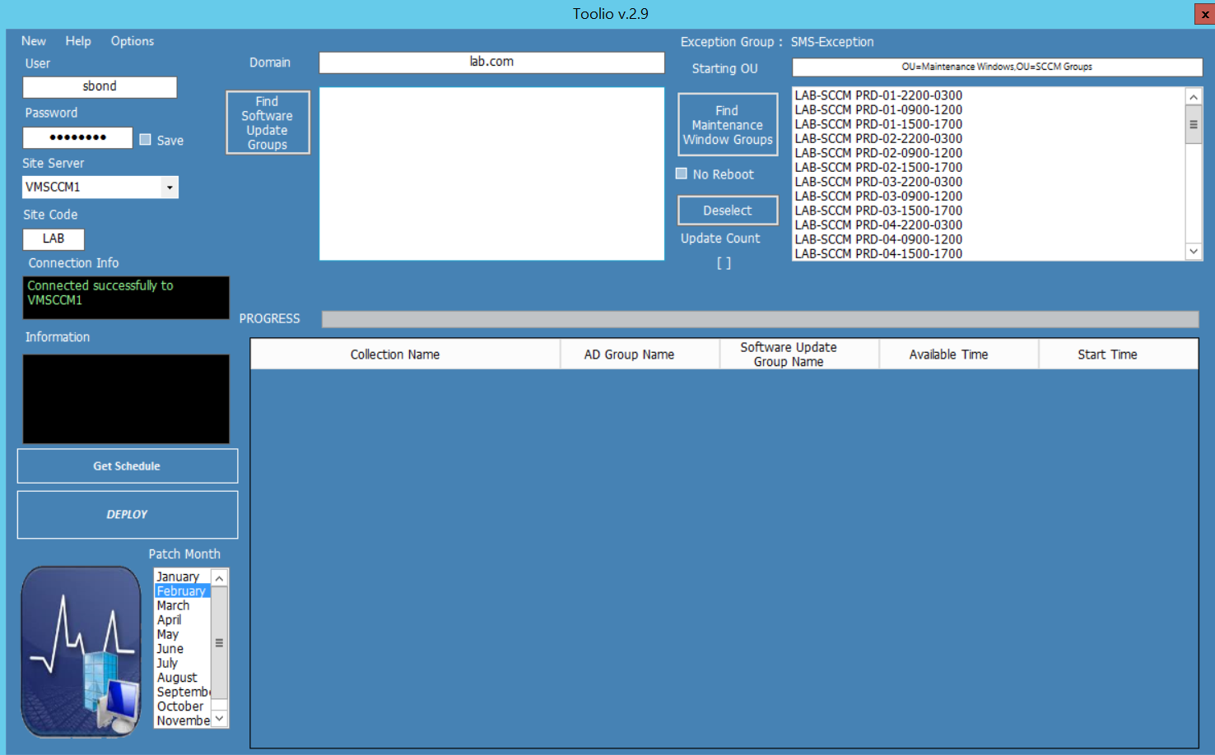

  - Find Maintenance Window Groups
This searches AD under the Starting OU for all the SCCM Update Deployment AD groups. Every group listed here will be deployed to unless a single group is selected. You might want to select a single group to test a deployment before deploying to all collections. Click Deselect to remove this selection, allowing you to deploy to all collections (based on these groups). The groups are recognised here through the use of a regular expression so it is important they are created properly. Should they need recreating for any reason, there is a utility under New | AD Groups to create them.

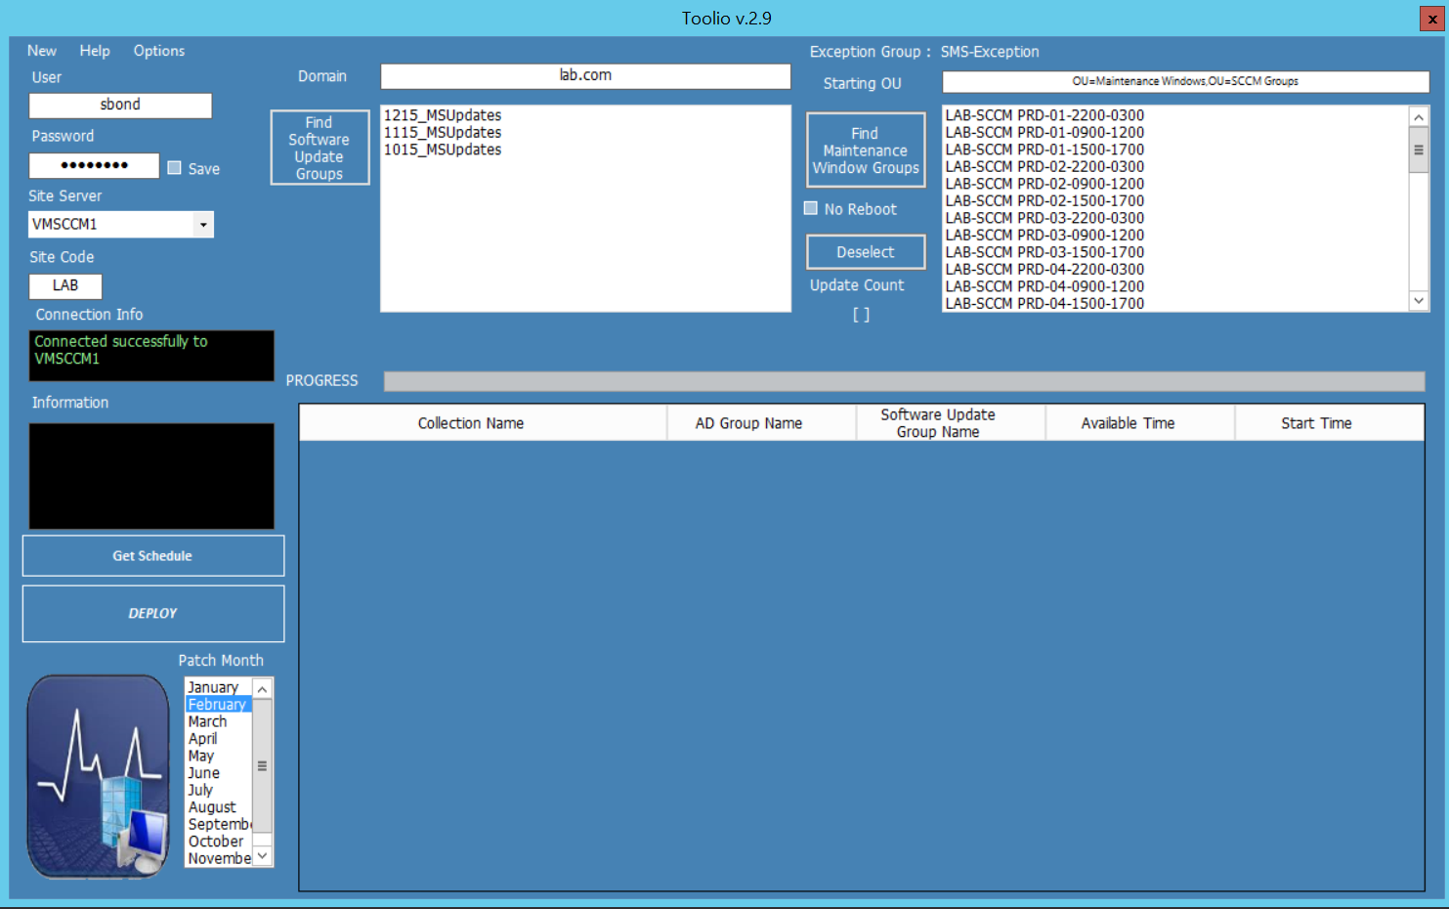

  - Find Software Update Groups
Next, select this to list all the software update groups in SCCM. Again, this looks for a certain naming convention but is fairly flexible. Select the software update group (or groups) that you want to deploy. Multiple SUGs can be selected here. It is advised that you initially select a single AD group to test the SUG deployment with before deploying to all collections.

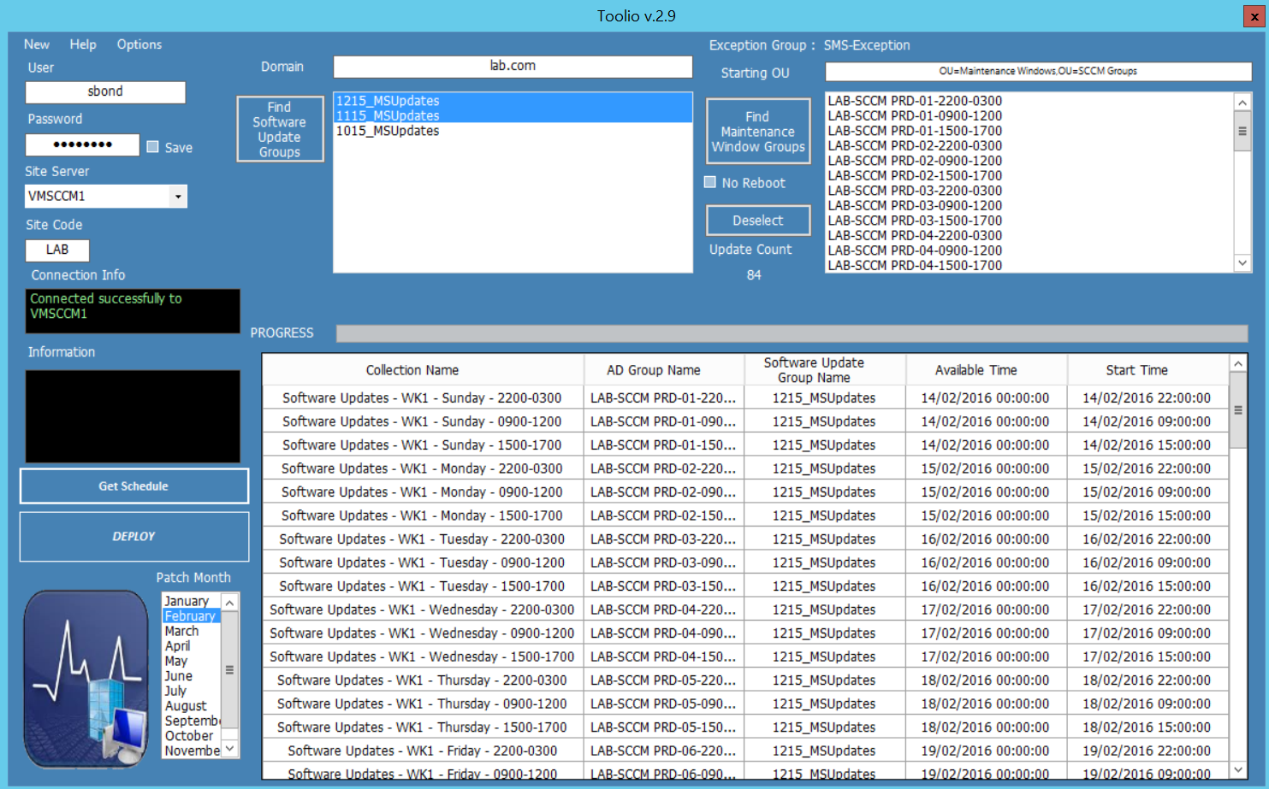

  - Get Schedule
After getting the AD groups and selecting the SUG(s) the next step is to click Select Schedule. This displays all the affected collections, the AD groups associated with those collections (by way of a collection query) the SUG name, the time the deployment will be made available from and the time the deployment will run automatically (start time).
Check that you’re happy how this all looks. Ensure that the WK number matches for the collection and the start and available times and dates are as expected. Although it isn’t shown in this table, if you have maintenance windows selected in the options menu then the MW will also follow the schedule associated with the collection / AD group name.

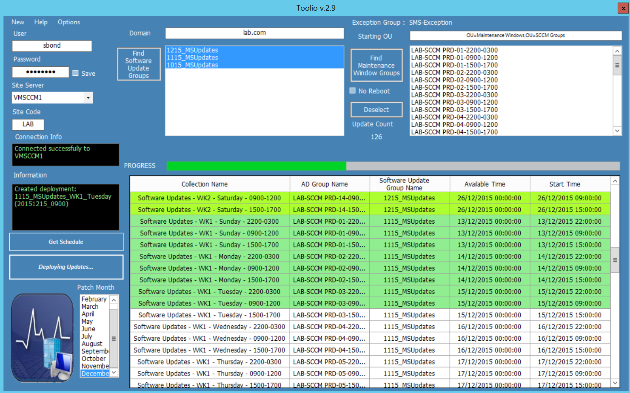

Deploy
Once you’re entirely satisfied with the schedule, click deploy to roll out the SUG(s) to all collections displayed in the grid. As alluded to earlier, it is recommended for peace of mind to initially roll out to a single collection (ideally containing no machines) just to ensure it all does exactly what you expect it to. Assuming this is as it should be, click deselect to remove the selected AD group and follow the procedures above to deploy to all collections. There are one or two prompts that will appear depending on options selected to ensure you’re aware of everything that will be affected. A progress bar will be displayed during deployment. As the deployment progresses each gridline will change colour. Light green indicates the deployment has already been applied to the collection, darker green mean the deployment to the collection is successful and red indicates a problem.

5.0 Other Features

Menu Items
  - New - This was covered earlier under AD Groups and Collections

  - Help - Quick reference to everything contained in this document. Also contains an About... box.

  - Options
5.3.1 Allow install and reboot outside maintenance window - When a software update group is deployed, in that deployment under ‘User Experience’ there are two checkboxes under Deadline behaviour. By default these checkboxes won’t be ticked meaning that no updates or reboots will happen outside of any pre-determined maintenance window. If the option is selected on the tool, then it will tick these two checkboxes for all deployments, allowing software updates or any other software installation to override the maintenance windows.
    - Dual Environment – This assumes you have two environments, one for NPD (non prod) and one for PRD (Prod). This essentially puts the deployment schedule on a four-week rota which is reflected by the collection names (WK1, WK2 are NPD, WK3, WK4 are PRD). Not all environments would necessarily follow this pattern and may require PRD to be WK1 & WK2 for example.
    - Add Maintenance Windows - Check this option to deploy maintenance windows based on the month’s patch schedules at the same time you deploy updates.
    - Clear All Maintenance Windows - This will go through all software update deployment collections and remove the defined maintenance windows associated. This might be required if it is decided that MWs are no longer needed.

Patch Month

This allows you to retrospectively deploy software update groups against a time frame set in the past. If a machine is in a collection deployed to in this manner, be aware that the software updates included in the SUG will get deployed to the collection immediately. If maintenance windows are applied to that collection, then updates will take place during the next maintenance window providing the machine doesn’t already have those updates. You may want to use this feature if a SUG for a particular month is accidentally deleted. It will always be assumed that any month you select will be in the past.
On the whole this feature should (and is likely) be used rarely.

Miscellaneous

7.1 All text boxes and checkboxes should automatically retain their settings when you close the application. The only exception is Password where there is a checkbox to ensure it retains your password. If you select to retain your password, it is cryptographically stored as a SHA1 hash in the registry.
  - Site Server has a drop-down with several names. Although new names can’t be added to the combobox, you can manually enter a new server name if required (and you can access it) and this server name will be remembered next time. If you tab out of the combo box, the tool will automatically search for a connection to the server name that is displayed. If you have any issues check the user and password data boxes.
  - The Site Code box is automatically populated via a WMI call when the application successfully connects to the server in the Site Server box.
  - Errors and information are mostly displayed under information text box. Errors appear in red, other information in green.

